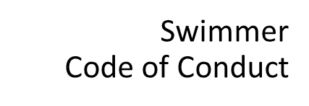
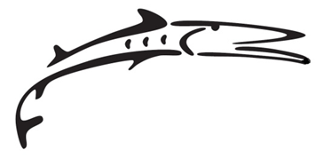
COVID-19 Revision
Green YMCA Barracudas
Swimmer Code of Conduct

The Green YMCA Barracudas strive to provide a meaningful experience for swimmers at all levels with emphasis on helping swimmers exemplify the YMCA core values of Caring, Honesty, Responsibility and Respect.

As a swimmer on the Green YMCA Barracudas, I will abide by the following code of conduct:
All swimmers will be at practice on time with all required equipment including facemasks as a Covid safety measure. Swimmers will not be permitted to join practices late without prior notice to, and permission from the coach.
All swimmers will follow the directions and instructions of the coaching staff and display proper respect and sportsmanship toward coaches, officials, administrators, teammates, competitors, aquatic staff and the public at all times. Swimmers must remain socially distanced from one another utilizing the markers on the deck and in the pool.

Cell phones/Camera/Recorders: The use of cell phones/tablets/ipads/cameras by swim team members in the locker room is prohibited. While in the locker room, swimmers must keep their phones and any other device with a camera stored in their bag or locker at all times. No cameras or recording devices may be used in the locker rooms. NO EXCEPTIONS. Taking photos, videos, or recordings of any type while in the locker rooms or changing areas may result in immediate removal from the team.

Locker Rooms: Parents are responsible for their child’s behavior in the locker rooms. Only one person is permitted in a shower stall at a time unless they belong to the same family. Horseplay, running and yelling will not be tolerated by the YMCA staff.

Team members are reminded when competing in meets, traveling on trips and attending other meet-related functions, they are representing both themselves and the Green YMCA Swim Team. Athlete behavior must positively reflect the high standards of our team.
All swimmers will report any inappropriate behavior to the coaching staff immediately upon recognizing or hearing about such bad behavior.

Unacceptable Behaviors:

- Insubordination to any coach, meet official, parent volunteer or facility staff.
- Displaying or promoting unsafe actions in or around the pool or locker room.
- Fighting, bullying or disorderly or disruptive conduct.
- Disrespectful or damaging behavior or actions in our facility or at ‘away’ meet locations.
- Team members will refrain from any illegal or inappropriate behavior.
- Use of inappropriate language or humor will not be tolerated.

Consequences for failing to comply with the Green Y Swim Team Code of Conduct:

Verbal reprimand, suspension, or dismissal from the team.
Possible ineligibility for future swim meets.
Removal from one or more events of a competition.

I have read and understand the GYB Swimmer Code of Conduct and agree to adhere to the above conditions.

Swimmer’s Name (printed)___________________ Swimmer’s Signature___________________

Parent’s Signature_________________________________ Date________________________

